



USABO SEMIFINAL EXAMINATION

March 27 to March 31, 2017

Read the directions included with the *Student Certification Form* provided by your teacher. Be certain to complete all requested information and to sign the Student Certification Form. Your exam cannot be graded without completion of this form. Use your scantron to answer all questions in Parts A and B.

***PART A: Each question is valued at 1 point unless indicated otherwise. Animal 15 Questions***

# For your independent research, you transferred lymphocyte populations between syngeneic mice. You irradiated recipients first to ablate (get rid of) existing lymphocytes, then transferred defined cell populations from donors of same genetic background. The result is shown below.

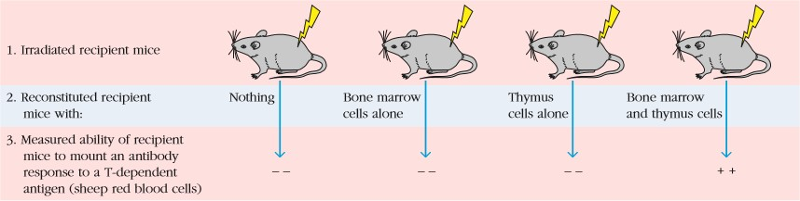

1. **What does this experiment tell us? Choose ALL that apply.**
   1. Both B cells and T cells can produce antibodies.
   2. Both B cells and T cells have memory functions.
   3. Both B cells and T cells are required for an antibody response.
   4. B cells are required for an antibody response in the absence of T cells.
   5. B cells and T cells are co-localized and produce synergetic effects in bone marrow and thymus.
2. **In 2090, a human population is found that is resistant to HIV. To examine what conferred such an evolutionary advantage on this population, specifically HIV entry, the clinically healthy mutations below were examined. To produce this advantage, which of the following would have to become dysfunctional?**
   1. CD8 receptor.
   2. Chemokine co-receptor of the host cell.
   3. MHC II molecule.
   4. Reverse transcriptase.
   5. Unique histone marker from HIV.
3. **Which of the following statements is NOT true of multiple sclerosis (MS)?**
   1. Loss of myelin is a prominent component of MS pathology.
   2. Loss of oligodendrocytes is a prominent component of MS pathology.
   3. MS is caused by a collection of genetic and environmental factors, but not necessarily by a single genetic defect.
   4. Autoimmune T cells are generated within the CNS by autoantigen without crossing the blood-brain barrier.
   5. One of the most feasible laboratory tests to diagnose MS is to examine the protein or antibodies in cerebrospinal fluid.
4. **Which of the following type of vaccine would most likely to be the most effective, but the least safe?**
   1. Live, attenuated vaccines.
   2. Recombinant DNA vaccines.
   3. Killed or inactivated vaccines.
   4. Vaccines derived from subunits (part of virus).
   5. Vaccines made of purely monoclonal antibodies for the antigen.
5. **Order the following events correctly in the contraction of smooth muscle tissue.**
6. **Calcium ions bind to calmodulin.**
7. **The thick filament pulls on a thin filament in muscle contraction**
8. **Phosphate groups are removed from ATP and bound to globular myosin heads**
9. **Myosin light-chain kinase is activated.**
   1. I, II, III, IV.
   2. I, III, IV, II.
   3. I, IV, III, II.
   4. IV, I, III, II.
   5. III, IV, I, II.
10. **A patient comes to your clinic and a few blood tests reveal elevated blood levels of gonadotropins. An assay of the pituitary gland does not reveal any abnormalities in his pituitary function. What else could be a plausible explanation for his heightened gonadotropin levels?**
    1. A genetic mutation in his primary spermatocytes is resulting in non-viable sperm.
    2. Aromatase enzymes in the Sertoli cells have become hyperactive and are producing heightened levels of estradiol, which promotes gonadotropin release.
    3. The Leydig cells have stopped responding to LH and are producing less testosterone, which helps regulate the function of the pituitary.
    4. The hypothalamus is producing abnormally low levels of GnRH.
    5. The Sertoli cells have become hypersensitive to FSH.
11. **Nitroglycerin (the key ingredient in dynamite) is sometimes prescribed for heart disease patients. Within the body, the nitroglycerin is converted to nitric oxide. Why would you expect nitroglycerin to relieve chest pain in these patients based on your knowledge?**
    1. Nitric acid will stimulate the production of endorphins; thus you will perceive less pain.
    2. Nitric acid will depolarize neurons and the neurons will no longer be able to send any signals.
    3. Nitric acid will decrease the activity of pain receptors (mechanoreceptors) specifically near the heart; thus you will perceive less pain.
    4. Vasodilation promoted by nitric oxide from nitroglycerin increases blood flow, providing the heart muscle with additional oxygen and thus relieving the pain.
    5. Vasoconstriction promoted by nitric oxide from nitroglycerin decreases blood flow, providing the heart muscle with less oxygen and thus relieving the pain.
12. **In 1995, during a Monday morning rush hour in Tokyo, Japan, five terrorists dropped bags containing a chemical compound called *sarin,* which is classified as a weapon of mass destruction, into subway cars. Over 5,000 people were sickened. Sarin forms a covalent bond with acetylcholinesterase, an enzyme that degrades ACh. Understanding the role of acetylcholinesterase in the body, which of the following would be symptoms of sarin poisoning? Select ALL that apply.**
    1. Dilation of pupils,.
    2. Drooling.
    3. Muscles go into a tetanic seizure and cannot relax.
    4. Nausea.
    5. Respiration ceases.
13. **Which statement below is NOT true of lymphatic systems and lymph nodes?**
    1. Naïve lymphocytes frequent lymph nodes.
    2. New lymphocytes enter circulation via the blood.
    3. Most lymphocytes in tissues get back into circulation via lymphatic vessels.
    4. From circulation, lymphocytes enter secondary or tertiary lymphoid tissues via veins.
    5. Lymph nodes provide a place for the antigens and mature lymphocytes to interact and i nitiate the adaptive immune response.
14. **If you were to have elevated levels of the cells shown below (stained red by the acidic dye carbol chromotrope), it may be an indication of: Select ALL that apply, it may be an indication of: Select ALL that apply.**

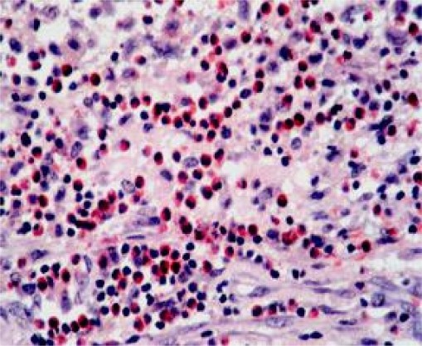

* 1. Allergic reaction.
  2. Cancer.
  3. Chickpox.
  4. Crohn’s disease.
  5. Parasitic infection.

1. **Studies show that prior exposure to donor MHC molecule leads to accelerated graft rejection. What can you conclude based on this outcome?**
   1. T lymphocytes can mediate graft rejection.
   2. B lymphocytes can mediate graft rejection.
   3. Graft rejection shows memory and specificity.
   4. Both B and T lymphocytes mediate graft rejection.
   5. Graft rejection is mediated by the innate immune system.
2. **Cytotoxic antibodies that are reactive against antigens expressed on grafted tissue cause:**
   1. Activation of cytotoxic T cells, causing hyperacute rejection.
   2. Delayed rejection of the transplant.
   3. Direction against human leukocyte antigens (HLAs).
   4. Hyperacute rejection.
   5. Rejection when present in donor.
3. **Examine the diagram below and select from the chart the correct set of actions for the circular muscles at Points 1, 2, 3.**

|  |  |  |  |
| --- | --- | --- | --- |
|  | **Point 1** | **Point 2** | **Point 3** |
| **A** | **Contracted** | **Relaxed** | **Contracted** |
| **B** | **Contracted** | **Contracted** | **Relaxed** |
| **C** | **Contracted** | **Relaxed** | **Relaxed** |
| **D** | **Relaxed** | **Relaxed** | **Contracted** |
| **E** | **Relaxed** | **Contracted** | **Contracted** |

1. **Molecule M is being processed by the nephrons. Using the data below, determine Molecule M’s excretion rate.**

* **Molecule M is filtered at a rate of 8 μg/minute.**
* **Molecule M is reabsorbed at a rate of 7 μg/minute.**
* **Molecule M is not secreted.**
  1. Molecule M is excreted at a rate of 8 μg/minute.
  2. Molecule M is excreted at a rate of 7 μg/minute
  3. Molecule M is excreted at a rate of 7.5 μg/minute.
  4. Molecule M is excreted at a rate of 15 μg/minute.
  5. Molecule M is excreted at a rate of 1 μg/minute.

1. **At the cellular level, what is(are) the relevant process(es) in graft vs host disease?**
2. **The recipient T cells encountering donor antigen-presenting cells.**
3. **The recipient B cells encountering donor antigen-presenting cells.**
4. **The donor T cells encountering recipient (host) antigen-presenting cells.**
5. **The donor B cells encountering recipient (host) antigen-presenting cells.**
   1. I.
   2. I, II.
   3. III.
   4. III, IV.
   5. I, II, III, IV.
6. **Below are diagrams of two sets of apparatus. The apparatus in Figure I is used for SDS- PAGE (polyacrylamide gel electrophoresis) and the apparatus in Figure II is used for DNA agarose gel electrophoresis. Which letters indicate the anode on each apparatus? B, D**

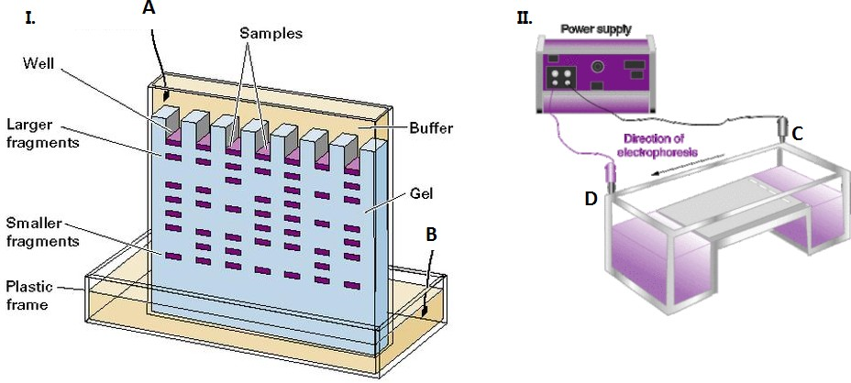

1. **During cell division of the organisms listed below, in which organism would the following events occur?**

* **Chromosomes attach to the nuclear envelope, which remains intact during cell division.**
* **Microtubules pass through the nucleus inside cytoplasmic tunnels, reinforcing the spatial orientation of the nucleus, which then divides in half.**
  1. Bacteria.
  2. Diatoms.
  3. Dinoflagellates.
  4. Humans.
  5. Yeasts.

1. **Carbon dioxide produced as a byproduct of cellular respiration is transported via the blood stream in which of the following forms? Select all that apply.**
   1. CO2 bound to hemoglobin.
   2. Carbonic acid.
   3. Fatty acid chains.
   4. Sodium bicarbonate.
   5. Dissolved CO2 gas.
2. **A 5g food sample is diluted with 0.85% saline to a total volume of 50 mL. A 1 mL sample is then diluted, again with 0.85% saline, to a total volume of 10 mL, a 0.1 mL sample from this solution is diluted to 1 mL total, and again 0.1 mL of that solution is diluted to a volume of 1 mL, 0.1 ml of that final dilution is spread onto a plate containing 25 mL of nutrient agar and incubated at 37°C for 1 day. A total of 300 colonies are counted. Determine the number of colonies colony forming units (CFU)/g of the original food sample.**
   1. 3.00×105 CFU/g.
   2. 3.00×106 CFU/g.
   3. 3.00×107 CFU/g.
   4. 3.00×108 CFU/g.
   5. 3.00×109 CFU/g.
3. **Observe the following equations that may be used to calculate osmolarity: Calculated osmolarity = 2 [Na+] + 2 [K+] + [Glucose] + [Urea] (all in mmol/L)**

Calculated osmolarity = 2 [Na+] + [Glucose] + [Urea] (all in mmol/L)

Is the following statement True (Use A) or False (Use B)?

The doubling of sodium accounts for the negative ions associated with sodium and the exclusion of potassium approximately allows for the incomplete dissociation of sodium chloride. B

1. **Each of the following statements concerning the Gram stain is correct except:**
   1. *Escherichia coli* stains pink because it has a thin peptidoglycan layer.
   2. *Mycoplasma pneumoniae* is not visible in the Gram’s stain because it does not have a cell wall.
   3. *Mycobacterium tuberculosis* stains blue because it has a thick lipid layer.
   4. *Streptococcus pyogenes* stains blue because it has a thick peptidoglycan layer.
2. **Which of the following is NOT true of different phases in M phase in animal cells?**
   1. Prophase – asters are formed for the first time during this phase.
   2. Anaphase – The cell elongates as the non-kinetochore microtubules lengthen.
   3. Telophase – Any remaining spindle microtubules are polymerized for later division.
   4. Cytokinesis – A contractile ring of actin microfilaments associated with molecules of the protein myosin forms the furrow.
   5. Metaphase – the kinetochores of the sister chromatids are attached to kinetochore microtubules coming from opposite sites.
3. **Would a sodium-potassium pump be considered to be a co-transporter? Why or why not?**
   1. It may or may not be a co-transporter depending on its environmental surroundings.
   2. Yes, it is a co-transporter because two ions are transported down their respective electrochemical gradients.
   3. No, it is not a co-transporter because two ions are transported against their respective electrochemical gradients.
   4. Yes, it is a co-transporter because it utilizes ATP to pump its ions out to couple its energy to pump sucrose inside the cell.
   5. No, it is not a co-transporter because co-transport requires hydrogen ions, but sodium- pump transporters do not need hydrogen ions.
4. **You expressed membrane proteins that consist of multiple subunits in *E. coli*, but they aggregate and all went into inclusion bodies and became insoluble. You would like to isolate inclusion bodies using a high concentration (8M) of urea and refold them in vitro so that you can make your proteins functional. To do so, you lysed the cells, solubilized the inclusion bodies, spun down, and took the supernatant. Which of the following statements best describes the chemical nature of supernatant solution?**
   1. All proteins are linearized and the solution is acidic.
   2. All proteins are linearized and the solution is basic.
   3. All proteins are linearized and the solution is neutral.
   4. All proteins’ subunits are separated with the structures retained and the solution is acidic.
   5. All proteins’ subunits are separated with the structures retained and the solution is basic.
5. **What is the importance of the structure shown below?**

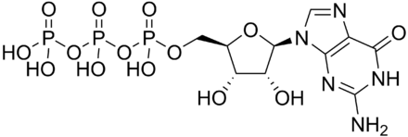

* 1. Required for mRNA to be exported out of the nucleus.
  2. Adds a cap to the 5’ end of mRNA by making a 5’-5’ triphosphate linkage
  3. Used for transcription of all RNA, including coding and non-coding RNAs.
  4. Adds multiple tails to the 3’ end, which protect the 3’ end from degradation.
  5. Used only for transcription of other types of non-coding RNA, including siRNA, miRNA, and tRNA.

1. **Hayflick Limit refers to the phenomenon in which cells in culture can only divide a certain number of times before they become senescent. What is the molecular mechanism behind this phenomenon?**
   1. Associated, most likely, with the nutrient deficient condition, which triggers autophagy.
   2. Associated telomeres with each cell's DNA will get slightly shorter with each new cell division until they shorten to a critical length.
   3. Inhibitory effects of certain components of cell media that cause depolymerization of microtubules.
   4. Overexpression of active telomerase.
   5. Suppression of active telomerase expression.
2. **Which of the following is a homologous structure shared by the two listed animals?**
   1. Dorsal fins of the bottlenose dolphin and the hammerhead shark.
   2. Wings capable of powered flight in a pterosaur and in the horseshoe bat.
   3. Hind leg skeleton of the kangaroo and the kangaroo rat.
   4. Teeth of the lamprey and the hammerhead shark.
   5. The camera-type eyes of squids and of lampreys.
3. **The following observations have been made about the human louse, which only colonizes human beings. Lice that infest head hair are not found elsewhere on the body, while lice that infest body hair and clothing are not found in head hair. Body lice have transmitted human diseases such as epidemic typhus, while head lice have never been reported to do so. Body lice and head lice are indistinguishable under the microscope or after dissection, and fertile hybrids result when both types of lice are reared together in the laboratory. Which species definition would argue for the separation of human head lice and body lice as different biological species based (only) on the information given?**
   1. Typological.
   2. Morphological.
   3. Biological.
   4. Ecological.
   5. Phylogenetic.
4. **The image below depicts the inheritance of a rare skin disorder in four generations of a family; the disorder has 100% penetrance. Which of the following choices describes the most likely mode of inheritance of this skin disorder?**

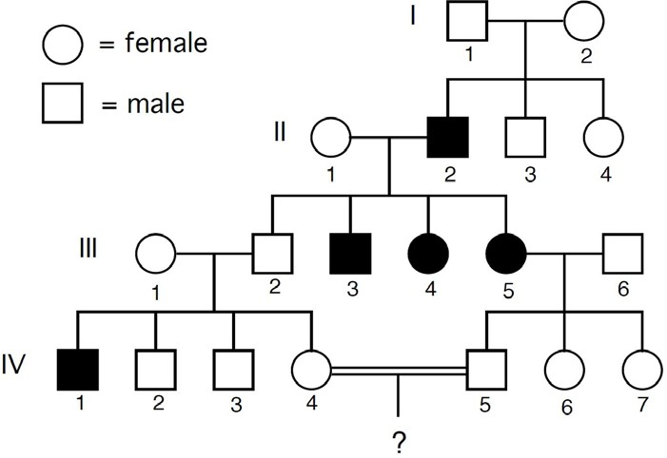

* 1. Autosomal dominant.
  2. Autosomal recessive.
  3. Sex-linked dominant.
  4. Sex-linked recessive.
  5. Familial nondisjunction.

1. **In domestic cats, hair color is determined by multiple gene loci. The Brown/eumelanin gene controls the amount of pigment produced in the hair shaft. Cats can have B, b, or c alleles at this locus. Cats with at least one dominant allele (B) are brown. bb and bc cats are chocolate colored, and cc cats are cinnamon colored. The white masking gene is epistatic to other pigmentation genes. WW or Ww cats will have a reduced number of pigment producing cells, and will be white. The color of ww cats will not be affected by the white masking gene. If a heterozygous brown (Bb) cat is crossed with a bcWw cat, what will the expected phenotypic ratio of the kittens be?**
   1. 4 White: 2 Brown: 1 Cinnamon: 1 Chocolate.
   2. 2 White: 1 Brown: 1 Chocolate.
   3. 2 Brown: 1 White: 1 Chocolate.
   4. 9 Brown: 3 Chocolate: 3 Cinnamon: 1 White.
   5. 9 White: 3 Brown: 3 Chocolate: 1 Cinnamon.

Questions 31 to 33. Honeybees are haplodiploid and reproduce sexually, meaning that females are diploid and males are haploid. In a given hive, only the queen bee reproduces – the other females are worker bees and do not mate even though they may be fertile.

In one hive, the queen bee has just mated with a single unrelated drone (a male bee). Their offspring includes a number of females and males. Use the following choices to answer Questions 32 to 34:

1. **0.125.**
2. **0.25.**
3. **0.50.**
4. **0.75.**
5. **1.00.**
6. **What is the coefficient of relatedness between two of the female offspring? D**
7. **What is the coefficient of relatedness between a female offspring and her brother? B**
8. **What is the coefficient of relatedness between a male offspring and his sister? C**
9. **Consider the following information for this question:**

* **Autosomal recessive genetic disorder.**
* **Very rare (Fewer than 20,000 US cases per year).**
* **Harmful quantities of cell membrane components known as gangliosides accumulate in the brain's nerve cells, eventually leading to the premature death of the cells.**

In the genetic disorder described above, which of the following organelles is most likely to be genetically impaired?

* 1. Golgi apparatus.
  2. Lysosomes.
  3. Mitochondria.
  4. Peroxisomes.
  5. Smooth Endoplasmic Reticulum (ER).

1. **All of the following are parts of the allopatric speciation by natural selection model, except:**
   1. Geographically isolated populations evolve or change in response to novel environments.
   2. Reproductive isolation evolves as a by-product of changes in other traits associated with adapting to new resources or environments.
   3. Selection against hybridization leads to exaggeration of signals to facilitate recognizing conspecifics (individuals of the same species).
   4. Changes among or between populations occur while populations are geographically separated.
   5. All of the above are parts of the allopatric speciation by natural selection model.

For Questions 36 to 38, use “A” for True and “B” for False.

1. **Animal diversity may be thought of as taxonomic diversity, genetic diversity, and/or morphological diversity. A**
2. **Evolutionary genetics has shown that although under certain conditions biodiversity can be created rapidly, under the most likely conditions the processes of generating biodiversity are very slow. A**
3. **Two major evolutionary mechanisms creating biodiversity are speciation (that is the origin of new species) and divergent evolution. A**
4. In assimilating inorganic compounds, plants are least likely to reduce which of the following com pounds?
   1. Carbon dioxide.
   2. Nitrate.
   3. Nitrite.
   4. Phosphate.
   5. Sulfate.
5. **Following pollination, indicate the sequence of tissues the pollen tube would pass through as it grows toward its rendezvous with the egg.**
   1. Micropyle → ovary → style → stigma → ovule Æ egg.
   2. Ovule → ovary → micropyle → stigma → style → egg.
   3. Style → ovary → ovule → stigma → micropyle → egg.
   4. Style → stigma → ovary → ovule → micropyle → egg.
   5. Stigma → style → ovary → ovule → micropyle → egg.
6. **Beginning on the inside of a plant cell and moving towards the outside of a plant cell, which of the following is organized correctly?**
   1. Plasma membrane → primary cell wall → secondary cell wall → middle lamella → cytoplasm.
   2. Cytoplasm → plasma membrane → middle lamella → secondary cell wall → primary cell wall.
   3. Plasma membrane → cytoplasm → secondary cell wall → primary cell wall → middle lamella.
   4. Middle lamella → secondary cell wall → primary cell wall → plasma membrane → cytoplasm.
   5. Cytoplasm → plasma membrane → secondary cell wall → primary cell wall → middle lamella.
7. **Arrange the following five events in the order that explains the bulk flow of substances in the phloem:**
8. **Sugar moves down to the sink.**
9. **Leaf cells produce sugar by photosynthesis.**
10. **Sugar is transported from cell to cell via the apoplast and/or symplast.**
11. **Solutes are actively transported into sieve tube elements.**
12. **Water diffuses into the sieve tube elements.**
    1. I, II, III, IV, V.
    2. II, I, IV, III, V.
    3. II, III, IV, V, I.
    4. II, IV, V, III, I.
    5. IV, II, I, III, V.
13. **The nefarious Dr. Du has gone across the nation planting the seeds of gigantic man- eating plants outside the laboratories of all biologists who have negatively reviewed his papers. Fortunately, there is still time to rescue your colleagues as the seeds only germinate once a century – which coincidentally happens next month. Which of the following plant hormones can you inject into the seeds to prevent them from germinating, foiling Dr. Du’s plot for the next hundred years?**
    1. Auxin.
    2. Gibberellins.
    3. Cytokinins.
    4. Brassinosteroid.
    5. Abscisic Acid (ABA).

Questions 44 to 47. Use “A” for True and “B” for False.

The direction of vapor phase water movement in soil is from

1. **Lower to higher vapor pressure. B**
2. **Cold soil to warm soil. B**
3. **Saline to nonsaline soil. B**
4. **Low to higher matric potential. B**

Questions 48 & 49: When a corn field is flooded, the activity of denitrifying bacteria in the soil increases. Indicate whether each of the two predictions are TRUE (A) or FALSE

(B) as they relate to the impact on soil fertility and the chemical process in the nitrogen cycle that will be affected.

1. **Denitrification is a process that involves conversion of plant-available forms of nitrogen**

in the soil (nitrate) to nitrogen gas, which is not available to plants. A.

1. **Increased denitrification will remove plant-available nitrogen from the soil, meaning it will not be available to the corn plants, making the soil less fertile, as Nitrogen (N) is a key micronutrient for plants. B**
2. 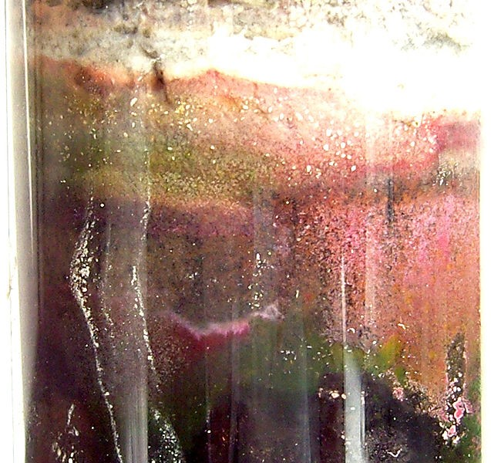**The Winogradsky column is a tool for investigating the microbial ecology of soil and sediment communities. In the column depicted below, sediment and water from a swamp was mixed with shredded newspaper and raw egg yolk as sources of carbon and sulfur, respectively. The column is made of nonporous glass. The top of the column was left open to the air, and the column was placed on a windowsill and kept moist. Over time, different colored layers developed in the column, reflecting different microbial populations. Select the answer below that does NOT correctly describe the expected composition of layers that can be observed in the Winogradsky column.**

*Source: https://commons.wikimedia.org/wiki/File:Purp_d_winogradsky.jpg.*

* 1. The black layer observed at the very bottom of the column would be expected to consist of anaerobic microbes.
  2. Anabaena would be expected to inhabit the photosynthetic zone of microbes at the top of the column. Purple photosynthetic microbes in the upper half of the column are dependent both on sunlight and on organic acids from other microbes; therefore, they would be considered photoautotrophs.
  3. Growth of green algae will decrease CO2 levels and increase O2 levels in the column during the day.
  4. Clostridium species of bacteria rely on cellulose breakdown products as a source of carbon and energy; therefore, they would be considered chemoautotrophs.

1. **The population of wolves in Yellowstone went from 137 to 121 in one year. Which of the following is the closest estimate for “r” if the population grew according to the exponential** growth during this time?
   1. -0.12.
   2. -0.08.
   3. 0.08.
   4. 0.12.
   5. 0.88.
2. **What’s “p” (the fraction of A1 alleles in the population) given the following frequencies of genotypes: A1A1 = 20, A1A2 = 50, A2A2 = 80?**
   1. 0.133.
   2. 0.233.
   3. 0.300.
   4. 0.700.
   5. 0.950.
3. **Based on the data above and your knowledge of the Hardy-Weinberg Law, calculate the expected number of individuals of each genotype. Then a chi-square value is calculated obtaining X2 = 6.39 and p = 0.041. With this information, one should conclude (most specifically:**
   1. The population is in Hardy-Weinberg equilibrium.
   2. The population is not in Hardy-Weinberg equilibrium.
   3. The population is moving toward Hardy-Weinberg equilibrium.
   4. The population is moving away from Hardy-Weinberg equilibrium.
   5. Nothing since there is not enough information.
4. **While analyzing a population dispersal pattern, it is discovered that the variance to mean ratio (s2/mean) is greater than 1, one could conclude that the population is**
   1. Decreasing.
   2. Dispersed in a clumped pattern.
   3. Increasing.
   4. Randomly dispersed.
   5. Uniformly dispersed.

For Questions 55 to 57, select the area of study from the list below that an ethologist would use to study the following questions:

* + 1. **Adaptive function.**
    2. **Development.**
    3. **Evolutionary history.**
    4. **Stimulus control.**

1. **Why do deer spend a lot of time near the boundary between the territories of different wolf packs? A**
2. **Why do monkeys that grow up isolated from other young monkeys lack normal social skills? B**
3. **Why primates (monkeys, apes, humans) all show threat and aggressions by opening**

the mouth and baring the teeth? C

### Given the phylogeny below, indicate which of the following statements about species A, B, C, D, and E is NOT correct. Note that branch lengths are proportional to the amount of divergence between clades.

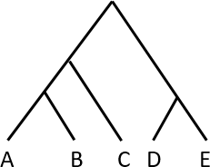

* 1. Species C is more closely related to species D than to species E.
  2. Species C is equally closely related to species A and B.
  3. Species D and E are the most closely related pair of species in this group.
  4. Species A is as closely related to species D as species B is to species E.
  5. Species B is more closely related to species A than to species C.

1. **Which of the following is the most accurate statement about echinoderms?**
   1. Their water vascular system is involved in locomotion but not in gas exchange.
   2. They possess a calcareous endoskeleton.
   3. They belong to the clade Radiata along with cnidarians.
   4. Their blastopore develops into the anterior end of their digestive tract.
   5. Most echinoderms lack a distinct larval stage.
2. **For influenza viruses, is responsible for binding the virus to the cell that is being infected while is used to remove receptors for influenza virus from newly formed virus particles, allowing these to be released and spread the infection.**
   1. Capsids; lipid envelopes.
   2. Lipid envelopes; capsids.
   3. Hemagglutinin; Neuraminidase.
   4. Neuraminidase; Hemagglutinin.

***PART B: Each question is valued at 2 points.***

1. **Which of the following correctly lists the events of gastrulation in frogs?**
2. **Dorsal lip formation.**
3. **Gray crescent formation.**
4. **Formation of ecto, endo, meso-derms.**
5. **Movement of cells to the surface by involution.**
6. **Invagination of the dorsal side of the blastula begins.**
   1. I, II, IV, V, III.
   2. II, I, IV, V, III.
   3. V, II, I, IV, III.
   4. V, I, II, IV, III.
   5. I, II, IV, V, III.
7. **You are analyzing the onset of action potential in a neuron in response to a specific stimulus. You add a drug that blocks the voltage gated K+ channels and observe that the membrane potential still reaches the resting level (although at a slower rate) due to the functioning of…**
   1. Voltage gated sodium channels.
   2. Leaky potassium channels.
   3. Sodium potassium ATPase pump.
   4. Leaky sodium channels.
   5. Proton pump.
8. **The following are the traces of action potential to 5 and 50pg/L of hypocretin, an inhibitory neurotransmitter.**

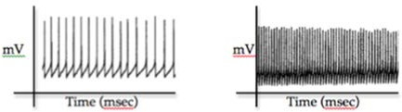

**Trace A Trace B**

Based on Trace A and Trace B shown above, select the correct option(s) from below.

* 1. Trace A is the response to 5pg/L and Trace B is the response to 50pg/L of hypocretin.
  2. Trace A is the response to 50pg/L and Trace B is the response to 5pg/L of hypocretin.
  3. Hypocretin acts by blocking the voltage gated Na+ channels.
  4. Hypocretin acts by activating the voltage gated K+ channels.
  5. Hypocretin acts by regulating the ligand-gated channels.

Questions 64 to 66. The RB gene encodes the retinoblastoma protein (pRB). *Note:* As shown below, the dephosphorylated pRB protein is active in G1 phase. pRB binds to the transcription factor E2F and prevents E2F mediated G1🡺 S transition. The Cyclin D- Cdk4 complex produced during G1, phosphorylates and thereby inactivates pRB. This allows the cell to enter S phase. The p16 protein inhibits the Cyclin D-Cdk4 complex.

**G1**

**S**

**Cyclin D**

**pRB**

**Cdk4**

**E2F**

**p16**

1. **What is the DNA content of a mutant somatic cell that has a constitutively active pRb?**
   1. n
   2. 2n
   3. 4n
2. **In which process(s) are the proteins encoded by the target genes of E2F most likely to function?**
   1. DNA replication.
   2. RNA stabilization.
   3. Splicing.
   4. Transcription.
   5. Translation.
3. **At what frequency would a p16 temperature-sensitive mutant, grown at the non- permissive temperature (42 °C), divide compared to the cells grown at the permissive temperature (37 °C)?**
   1. Higher.
   2. Lower.
   3. Same.
4. 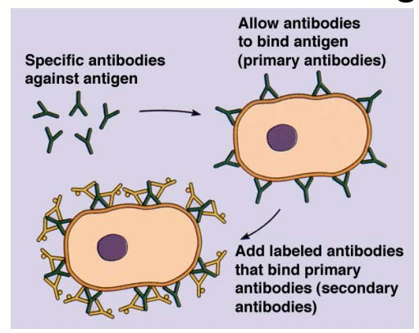**You would like to carry out immunofluorescence (IF, or immunostaining) for the proteins called Rab5, an early endosomal markers, in human cancer cell line. A brief overview is shown below.**

Your host species of primary antibodies was mouse with IgG. You would now like to use the secondary antibodies to amplify the signals. Which of the following is a true statement of secondary antibody for your purpose?

* 1. Your secondary antibodies should be from human.
  2. Your secondary antibodies should be from donkey.
  3. Your secondary antibodies can be monoclonal, but cannot be polyclonal.
  4. You can block with human serum to reduce non-specific binding during staining procedure.
  5. You can block with mouse serum to reduce non-specific binding during staining procedure.

1. **Your buddy drinks a gallon of water, which of the following responses should his body show as it struggles to keep him alive (ANF = atrial natriuretic factor, ADH = antidiuretic hormone)?**
   1. Decreased ANF release, decreased sympathetic activity, decreased ADH release.
   2. Decreased ANF release, increased sympathetic activity, increased ADH release.
   3. Increased ANF release, decreased sympathetic activity, decreased ADH release.
   4. Increased ANF release, increased sympathetic activity, decreased ADH release.
   5. Increased ANF release, increased sympathetic activity, increased ADH release.
2. **Which sequence occurs during the digestion and absorption of fats?**
   1. Bile salts → digestion, lipase → emulsification, chylomicrons → packaging of fats.
   2. Bile salts → digestion, lipase → packaging of fats, chylomicrons → emulsification
   3. Bile salts → packaging of fats, lipase → emulsification, chylomicrons → digestion.
   4. Bile salts → emulsification, lipase → digestion, chylomicrons → packaging of fats.
   5. Bile salts → emulsification, lipase → packaging of fats, chylomicrons → digestion.

For Questions 70 to 72, use the following graph.

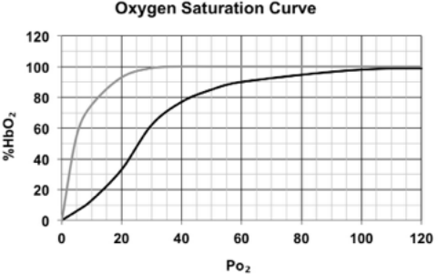

**Key**

Myoglobin Hemoglobin

1. **Approximately what is the HbO₂ for blood (Hb) at Po₂ = 35** Torr**?**
   1. 60%
   2. 72%
   3. 100%.
2. **What Po₂ is required to saturate Hb to 40%?**
   1. 23 Torr.
   2. 46 Torr.
   3. 80 Torr.
   4. 100 Torr.
3. **A mountain climber at high altitude has an alveolar Po₂ of 50 Torr and a tissue Po₂ of 15 Torr. How much oxygen (in units of %HbO₂) gets delivered by the blood under these circumstances?**
   1. 20%.
   2. 40%.
   3. 60%.
   4. 80%.
4. **During the cardiac cycle, the atrioventricular valves close because**
   1. Pressure in the atria exceeds pressure in the ventricles due to atrial contraction.
   2. Pressure in the ventricles exceeds pressure in the atria due to atrial contraction.
   3. Pressure in the atria exceeds pressure in the ventricles due to ventricular contraction.
   4. Pressure in the ventricles exceeds pressure in the atria due to ventricular contraction.
   5. They’re stimulated by the sympathetic nervous system.
5. **Birds have nucleated erythrocytes, while mammals have enucleated erythrocytes. Which of the following is a plausible evolutionary explanation for the relationship between these cells? Select all that apply.**
   1. Birds are descendants of reptiles, which have nucleated erythrocytes.
   2. Mammals evolved under lower atmospheric oxygen conditions in the Triassic, which favored the loss of the nucleus for greater oxygen-carrying capacity. In contrast, birds evolved in the Jurassic with higher atmospheric oxygen levels.
   3. Avian erythrocytes perform a number of phagocytic functions in the immune system and therefore need to retain a nucleus.
   4. Both avian and mammalian erythrocytes retain mitochondria at maturity, indicating a possible evolutionary relationship.
   5. Instead of enucleated RBCs, birds evolved to satisfy increased oxygen demands by a flow- through respiratory system that is more efficient at oxygen transfer than the mammalian one.
6. **The maturation-promoting factor (MPF) is a cyclin-Cdk complex discovered to promote the onset of M-phase in the embryos of *Xenopus laevis*, the African clawed toad. Which of the following statements is MOST accurate?**
   1. The cyclin-dependent kinase component of MPF is degraded by the cyclin at the end of the M phase, when cyclin levels are at their maximum. The Cdk levels then gradually build up again.
   2. MPF binds to and phosphorylates DNA, which initiates the transcription of genes responsible for mitosis.
   3. MPF possesses kinase activity and, among other targets, phosphorylates proteins of the nuclear lamina, leading to the fragmentation of the nuclear envelope that is necessary for mitosis to proceed.
   4. Yeast cells with a temperature-sensitive loss-of-function mutation in cdc2 kinase, the yeast homolog of the vertebrate Cdk, are unable to divide and become polyploid as a result of multiple rounds of DNA replication without cell division.
   5. MPF kinase activity would be highest just before the G2 checkpoint, as the Cdk component degrades its cyclin partner to initiate mitosis.
7. **The bacterium *Serratia marcescens* has a red color when grown on nutrient agar, due to its production of a secreted pigment called prodigiosin. There are multiple genes involved in the synthesis pathway for prodigiosin. A microbiologist mutates a culture of**

*S. marcescens* with ultraviolet light and identifies 4 different colonies that are auxotrophs (no longer produce the red pigment). Auxotrophs are pink/orange, while the wild-type strain is dark red in color. However, *S. marcescens* auxotrophs can secrete and take up intermediate products of the biosynthesis pathway. For example, an intermediate molecule in the biosynthesis pathway can be secreted by auxotroph Strain A and taken up by auxotroph Strain B, if the two strains are grown close together on an agar plate. If auxotroph Strain B has the correct enzymes to process the intermediate molecule into prodigiosin, Strain B will regain the dark red color. Auxotroph Strains A to D were grown in pairs, with the resulting colors. Select the statements below which is TRUE about the biosynthesis pathway for prodigiosin, based on the results of this experiment. You can assume a simple biosynthetic pathway with no branching.

|  |  |
| --- | --- |
| **Pair of Strains** | **Color Results after Pairing** |
| **A and B** | **A is red, B is pink** |
| **A and C** | **A is red, C is pink** |
| **A and D** | **A is red, D is pink** |
| **B and C** | **B is pink, C is red** |
| **B and D** | **B is pink, D is red** |
| **C and D** | **C is red, D is pink** |

1. The Mutation in D affects the final enzyme in the prodigiosin pathway.
2. The Mutation in C is earlier in the pathway than the Mutation in B.
3. The mutation in A affects the final enzyme in the prodigiosin pathway.
4. The results can only be explained with at least 5 different enzymes in the prodigiosin pathway.
5. The mutation in C affects the final enzyme in the prodigiosin pathway.
6. **If only the concentration of K+ increased to 100 mM in the extra cellular fluid of a cell, the absolute value of the cell membrane potential would:**
   1. Decrease.
   2. Increase.
   3. Remain the same.
   4. Would fluctuate rapidly.
   5. Would fluctuate slowly.
7. **Neurons A and B are the only two presynaptic neurons that affect a particular postsynaptic neuron. If a single action potential arrives at A, but not at B, the postsynaptic potential increases. If A and B experience action potentials at the same time, the postsynaptic potential increases, but by less than when just A is active. Based on this information,**
   1. Neuron B must have effects that are excitatory, and the simultaneous effects of A and B are an example of spatial summation.
   2. Neuron B must have effects that are inhibitory, and the simultaneous effects of A and B are an example of spatial summation.
   3. Neuron B must have effects that are excitatory, and the simultaneous effects of A and B are an example of temporal summation.
   4. Neuron B must have effects that are inhibitory, and the simultaneous effects of A and B are an example of temporal summation.
   5. It’s impossible to tell from the information given.
8. **If gonadotropins (HCG, LH)) from human placenta were injected into a mature male,**

one might expect to see

* 1. A decrease in the activity of the testes.
  2. An increase in estrogen and progesterone.
  3. Increased sperm production by the testes.
  4. An increase in testosterone.
  5. A 28-day cycling of male hormones.

1. **A patient exhibits excessive irritability of the muscles and nerves; even minor stimuli result in tremors, cramps, and convulsions. Blood tests show an abnormally elevated concentration of phosphate and an abnormally low concentration of calcium These are symptoms of**
   1. Hyperadrenocorticalism.
   2. Hyperparathyroidism.
   3. Hyperthyroidism.
   4. Hypoparathyroidism.
   5. Hypothyroidism.
2. **In a 24-hour period, the kidney filters 180 L and produces 1.5 L of urine. Together the kidneys have 2 million glomeruli, how many mL of fluid are filtered by each glomerulus in 24 hours?**
   1. 0.089 mL.
   2. 0.89 mL.
   3. 8.9 mL.
   4. 0.09 mL.
   5. 0.9 mL.

## AB. 9.0 mL.

1. **A 1973 *Washington Post* quote about a gun shooting follows: “*The most serious wound, which at the onset many thought would cost the victim his life was just above the belt- line on the left side. It affected the pancreas, colon and portal vein, which supplies***

***blood to the stomach. The vein was almost severed in two.”* There is a biological error in this excerpt. Select the error from the responses below:**

* 1. The colon is nowhere near the indicated wound site.
  2. The pancreas is on the left side of the body.
  3. The portal vein does not supply blood to the stomach.
  4. A single bullet could not have hit both the pancreas and the colon.
  5. The listed wounds were not serious enough to endanger life.

1. **At the venule end of the capillary bed**
   1. The hydrostatic blood pressure is greater than the osmotic pressure of the blood.
   2. The hydrostatic blood pressure is higher than it is at the arteriole end.
   3. The hydrostatic blood pressure and the osmotic pressure are equal.
   4. The osmotic pressure of the blood is greater than the hydrostatic blood pressure.
   5. Water and dissolved materials leave the capillary.
2. **In the responses below are hormones matched with functions. Which one is False?**
   1. Melatonin—inhibits gonadotrophin secretion.
   2. Parathyroid hormone—regulates calcium phosphate balance.
   3. ACTH –stimulations the adrenal cortex.
   4. Oxytocin—stimulates water reabsorption by the kidneys.
   5. Prolactin—stimulates milk production by the mammary glands.
3. **Which statement below is true for an annelid and an arthropod?**
   1. Both exhibit indeterminate cleavage in early development.
   2. The blastopore becomes the anus in both.
   3. Both exhibit spiral cleavage.
   4. The mesoderm arises as out-pocketings of the endoderm in both.
4. **Arthropods and vertebrates may both be regarded, in a sense, as the most highly evolved representatives of their evolutionary lines. They have convergently evolved many striking similarities, presumably in response to similar section pressures. Which statement below is NOT TRUE about the similarity of the two groups?**
   1. Most members of both groups possess jointed appendages.
   2. At least some members of both groups have evolved wings.
   3. At least some members of both groups have a structurally distinct and highly specialized head region.
   4. In both groups the circulatory system has become highly specialized for oxygen transport, as is necessary in such active animals.
   5. Hinged jaws occur in both groups, though their evolutionary derivations are quite different.

### Questions 87 to 89. The plant *Arabidopsis arenosa* has a tetraploid cytotype, with four homologous copies of each chromosome that reassort freely with one another during meiosis to form diploid gametes. You are interested in studying the gene *ASY1*, which appears to play a role in adaptation to tetraploidy. You identify one individual that carries one copy of a rare allele *a,* and three copies of the wild-type allele *A*. You want to breed this individual with your wild-type stock to generate homozygous *aaaa* individuals. Note that *A. arenosa* is an obligate outcrossing species, meaning that individuals cannot self.

1. **Part 1. If you begin with individuals *AAAA* and *AAAa* as the parental generation and perform a series of crosses, what is the earliest generation in which you can obtain homozygous *aaaa* individuals?**
   1. F1.
   2. F2.
   3. F3.
   4. F4.
   5. F5.

### Part 2. In the final step of your breeding experiment above, you cross two *AAaa* individuals to generate a mix of *AAAA, AAAa, AAaa, Aaaa,* and *aaaa* individuals. What proportion of the progeny of this cross will be *aaaa* individuals?

* 1. 1/72.
  2. 1/36.
  3. 1/18.
  4. 1/9.
  5. 1/3.

### Part 3. Most tetraploids are self-compatible, which means that two gametes from the same individual can form viable offspring. In a self-compatible species, beginning with a selfing *AAAa* individual as the parental generation, what is the first generation in which you can obtain an *aaaa* homozygote?

* 1. F1.
  2. F2.
  3. F3.
  4. F4.
  5. F5.

1. **In the inherited form of the human disease CJD (Creutzfeldt-Jakob Disease), a mutation at amino acid #211 of the human prion protein leads to severe neurologic effects. The change, resulting from a substitution mutation, is from an E (Glutamic Acid; Glu) at amino acid 211 in the normal version of the protein to a K (Lysine; Lys) in the disease- causing form of the protein. Based on this information and what you know about protein biochemistry, which of the following statements below are correct? Select ALL that are correct.**

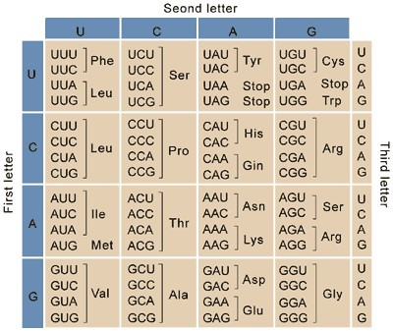

*Wikimedia Commons*

* 1. The change from E to K would be expected to increase the protein’s net negative charge at a neutral pH.
  2. The change from E to K could potentially impact ionic interactions in the tertiary structure of the prion protein.
  3. The E to K change is unlikely to impact the primary structure of the prion protein.
  4. The protein change is the result of a G to A change in the mRNA sequence of individuals with the disease-causing allele.
  5. The protein change may have been the result of a nonsense mutation in the original DNA sequence.

1. **A molecular biologist swabs the inside of the cheek of 10 pesticide applicators and 10 community members to isolate microbes from the oral microbiome. The biologist then isolates genomic DNA from the community of microbes on each swab, and uses PCR to amplify a segment of the 16S ribosomal RNA genes from the bacterial DNA in each sample. The resulting DNA is sequenced for use in identification of the bacteria in each sample, based on comparison to a 16S rRNA database. The biologist also takes cheek swabs and streaks them to nutrient agar plates for examination and identification of the resulting bacterial colonies. Select ALL the statements below that are TRUE.**
   1. The PCR amplification is likely to lead to contamination with 16S ribosomal RNA gene products from human cells.
   2. 16S ribosomal genes are translated by ribosomes in the bacterial cell into ribosomal proteins.
   3. A greater diversity of microbes are expected to be identified from the 16S procedure as compared to the nutrient agar procedure.
   4. Analysis of only 16S ribosomal sequences will fail to characterize the diversity of fungi in the sample.
   5. PCR utilizes RNA polymerase to generate new strands of DNA.
2. **A locus with two alleles M and m and a locus with two alleles N and n are linked on a single chromosome. Individuals homozygous for *M* and *n* are mated with individuals homozygous for *m* and *N*. Their offspring are test-crossed and yield the following results:**

|  |  |
| --- | --- |
| **Mn/mn** | **232** |
| **mN/mn** | **240** |
| **MN/mn** | **15** |
| **mn/mn** | **13** |

How many units apart are these genes on the chromosome?

* 1. 2.5
  2. 5.1
  3. 4.6
  4. 12
  5. 50

Questions 93 to 99. The following pedigree shows the mode of inheritance of a human disease that is associated with mutations in Gene A. *Note*: Individuals marrying into this family DO NOT have the disease-associated allele unless shaded and the pedigree is completely penetrant.

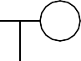

**1**

**2**

**4**

**5 6**

**7**

**8**

**9 10 11 12**

**13 14 15 16**

**17**

**18**

**19**

**3**

1. **What is the genotype(s) of Individual 9?**
   1. AA.
   2. Aa.
   3. Aa or AA.
   4. XAXA.
   5. XAXa .

AB. XAXA or XAXa. AC. XAXa.

1. **What is the genotype(s) of Individual 12?**
   1. AA.
   2. Aa.
   3. Aa or AA.
   4. XAXA.
   5. XAXa .

AB. XAXA or XAXa. AC. XaXa .

Continue to use the pedigree for Questions 95 to 99, but remove the rule that individuals marrying into the family cannot be carriers. Indicate whether the following statements are TRUE (A) or FALSE (B). The pedigree would be consistent with an autosomal recessive mode of inheritance if…

1. **Individual 3 were a carrier. *A***
2. **Individual 15 were a carrier. *A***
3. **Individual 16 were a carrier. *A***
4. **Individual 18 were a carrier. A**
5. **Individual 19 were affected. *A***
6. **A botanist takes a fresh spinach leaf and uses a hole-punch to create “leaf punches” for further experimentation. The botanist uses a syringe to create a vacuum and remove air trapped inside a sample of leaf punches. Next, the botanist sets up two cups, each under a white light that is suitable for photosynthesis. The cups are filled half-full with water; ten leaf disks are placed in each cup and sink to the bottom. In Cup A, the botanist takes a straw and exhales her breath for 1 minute while blowing bubbles into the water. To Cup B, nothing further is added. Then, she switches on the white lights above each cup. Eight minutes later, the botanist observes that in Cup A, 7 leaf disks have floated to the top of the cup; no leaf disks have yet floated to the surface in Cup B. Small bubbles are observed on the margins of the leaf punches in Cup A. Based on what you know about plant metabolism, select all of the following statements below that are TRUE? *Note: O2 is less soluble in water than CO2.***
   1. If the botanist switched off the lights at 8 minutes, additional leaf disks would be expected to rise in Cup A for the first few minutes, since the dark reactions can continue in the absence of light.
   2. If the botanist switched off the lights at 8 minutes, eventually the disks in Cup A would begin to sink, due to cellular respiration in the plant cells.
   3. When the lights are on, photosynthesis (but not cellular respiration) is occurring in Cup A. When the lights are off, cellular respiration (but not photosynthesis) is occurring in Cup A.
   4. The bubbles observed on the edges of the leaf punches at 8 minutes were formed through the action of rubisco.
   5. The pH of the water in Cup A would be expected to increase over the course of the experiment (between 0 and 8 minutes).
7. **Which of the following is FALSE?**
   1. C4 plants are considered to be of tropical origin.
   2. C3 plants are light saturated at lower levels of light than are C4 plants.
   3. C3 plants use water more efficiently than do C4 plants.
   4. C4 plants use nitrogen more efficiently than do C3 plants.
8. **The relative contribution of transpiration and evaporation to overall evapotranspiration by shading the soil surface by a plant canopy decreases evaporation, thereby increasing the contribution of transpiration. Use A for True and B for False. A**
9. **Along with the seed, the seed plants have evolved several additional adaptions to the land environment. All of the following have such an adaptation EXCEPT?**
   1. Flagellated gametes are not required for seed formation.
   2. The female gametophyte is protected from desiccation by the surrounding tissues of the sporophyte.
   3. The seed and/or associated structures serve as a means of dispersal.
   4. The method of seed formation introduces a new type of genetic recombination.
   5. The seed has its own food supply for the enclosed embryo.
10. **The concentric arrangement of the tree tissue systems characteristic of most dicot and monocot roots from the center to the periphery is**
    1. Cortex, epidermis, vascular cylinder
    2. Vascular cylinder, epidermis, cortex.
    3. Epidermis , cortex vascular cylinder
    4. Vascular cylinder, cortex, epidermis.
    5. Cortex, vascular cylinder, epidermis.
11. **The maintenance of plants under environmental conditions that greatly differ from their natural environments has revealed that most biological rhythms are**
    1. Quite variable.
    2. Endogenous.
    3. Temporary in nature.
    4. Not adaptive.
    5. Not influenced by environment’s conditions.

# Questions 106 to 108. Use “A” for True and “B” for False.

1. **A long-day plant with a critical photoperiod of 16 hours can still flower if the day length is only 8 hours provided the dark period is interrupted by a brief exposer to light. A**
2. **Unlike animals, plant responses to stimuli do not involved electrical impulses, but rather are mediated by rapid changes in the turgor of cells associate with the active transport of ions. B**
3. **Some plants sustaining insect damage are capable of communicating with other members of their species, stimulating the mobilization of chemical defenses again would –be attackers in those plants. A**
4. Increasing niche overlap leads to increasing:
   1. Commensalism.
   2. Competition.
   3. Predation.
   4. Mutualism.
5. **The main distinction between nutrient and energy dynamics in rangeland ecosystems is:**
   1. Nutrients flow through ecosystem components while energy is cycled.
   2. Nutrients cycle through ecosystem components while energy flows.
   3. Nutrients are confined to living portions of the ecosystem while energy is not.
   4. The main source of all nutrients is the soil while the sun supplies energy.
6. **Select all of the following that would be a benefit of wetland soils:**
   1. Protection from coastal flooding.
   2. Control and limit downstream flooding.
   3. Improved water quality.
   4. Wildlife habitat / diversity.
7. **If large carnivores in an ecosystem are killed off, the number of primary producers in the area may also decrease dramatically, even though the carnivores don't eat the primary producers. How do you explain this effect?**
   1. It is the result of a trophic inversion.
   2. The death of the carnivores leads to increased decomposition which pollutes the primary producers.
   3. The carnivores are most likely keeping the herbivore population in check.
   4. Angular stratification of the grazer biome occurs when the carnivores are killed.
8. **Suppose you belong to a cult living the Southwest U.S. and as part of the cult beliefs you may only eat Roadrunners. These birds feed exclusively on snakes (not really, but we’ll say so). The snakes are predators on Kangaroo Rats. K-rats are seed eaters. Your ration of Roadrunner in the cult headquarters compound amounts to one pound per day, which is barely enough food, but you can make it. About how many pounds of seeds per year must grow to sustain you?**
   1. 30.
   2. 40.
   3. 10,000.
   4. 36,500.
   5. Over 365,000.
9. **Use “A” for True and “B” for False. The halocline in marine biomes occurs where the low salinity surface water rapidly increases in salinity as depth increases. A**
10. **Two calls are produced by Tungara frogs: a one-note *whine* and a *whine+chuck*. If the *whine+chuck* call is more attractive to females than the *whine* call, why don’t males always use the whine+chuck call?**
    1. Behavior among the frogs changes from the necessity to attract females and to handle predation pressure.
    2. The “additional chuck” component signifies a territorial aggressive call directed toward males.
    3. The resident male will only use the *whine+chuck* call if he is both trying to attract females and defend his territory against intruder males.
    4. The *whine+chuck* call is harder to localize. Males mix the calls to make it easier to find the females.
    5. The *whine+chuck* call takes more energy so the males only use it when they have not been able to attract a female for a length of time.
11. **Which of the following is the best explanation for what appears to be a contradiction of behaviors in male lions, whereby the males will engage in infanticide, but allow cubs to eat a downed prey first? Males**
    1. Are altruistic toward cubs that may provide protection for them when those cubs become old enough to take over the pride.
    2. Kill all cubs that are not related to them, while making sacrifices for their own cubs since the dominant male has a short tenure in the pride.
    3. Kill cubs that are aggressive while feeding.
    4. Kill the weaker/slower cubs and provide the most support for the remaining cubs.
12. **Dogs often roll on dead animals. How would you describe this in terms of animal communication? Scent rolling is probably due to:**
    1. Deceit.
    2. Mutuality.
    3. Manipulation by receiver.
    4. Spite.
    5. Information for the pack.
13. **In the Plasmodium life cycle, the sporozoites produce merozoites, which are**

and are released from the of the host.

* 1. Diploid; erythrocytes.
  2. Diploid; hepatocytes.
  3. Diploid; sporozites.
  4. Haploid; erythrocytes.
  5. Haploid; hepatocytes.

1. **Which diagram represents a monophyletic group with a circle?**
   1. Taxon I and II.
   2. Taxon II andIII.
   3. Taxon I only.
   4. Taxon II only.
   5. Taxon III only.
2. **The most effective way to tell archaea from bacteria is to examine their:**
   1. Cells; archaea are eukaryotes and bacteria are prokaryotes.
   2. Cells; archaea are prokaryotes and bacteria are eukaryotes.
   3. Nuclear regions; the nucleus of an archaeon contains linear DNA but that of a bacterium does not.
   4. Chloroplasts; those of an archaeon have different pigments from those of a bacterium.
   5. DNA by sequencing; the differences between archaea and bacteria cannot be seen with a microscope.

Student Name Student ID#

***Place all answers to Part C, Questions 1 and 2, on these two pages. Additional sheets of paper may be used, if necessary. Be sure that each page has the Your Name and Your Student ID#. Please staple all pages for Part C together.***

# Question 1 (7 points)

The following diagrams depict two important functions in muscle physiology, the length-tension relationship and the force-velocity relationship, determined for single skeletal muscle fibers dissected from a frog, *Rana temporaria*. Such curves are consistent with the sliding filament model of skeletal muscle contraction.

The length-tension curve plots the maximum force (or tension) produced by the electrically stimulated muscle fiber while the fiber is held at different lengths and not allowed to shorten (i.e. an isometric contraction). It has been verified that the force is proportional to the amount of overlap of thin and thick filaments at lengths below 2.6 μm (i.e. when the resting tension is 0 N/mm2).

In the force-velocity curve, the initial velocity of an isotonically contracting muscle is plotted as a function of the afterload, which is the force (kept constant during the millisecond-long contraction) against which the muscle is contracting. It has been determined that the maximum velocity in the force-velocity curve depends only on the intrinsic speed at which the myosin heads can complete one cycle of cross-bridge formation and release.

The force-velocity curve shown on the right (labeled “A”) was obtained when the sarcomere length was set to 2.1 μm. Which of the labeled curves is the force-velocity curve observed when the sarcomere length is set to 1.6 μm? Support your answer for each choice.

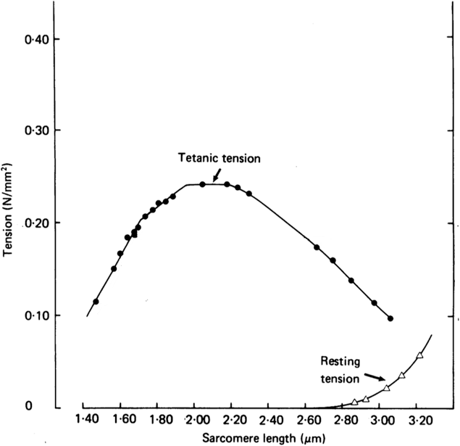

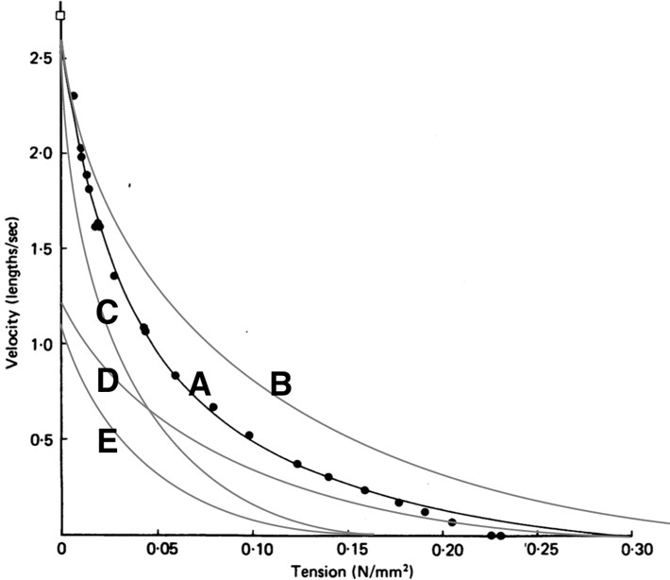

1. Curve A.
2. Curve B.
3. Curve C.
4. Curve D.
5. Curve E.

Answer C (*2 points*):

Rationale *(5 points*): When the length of the sarcomere is reduced to 1.6 μm, the maximum tension it generates also reduces, as can be seen in the length-tension curve in the left figure. As hinted in the question, this reduction in force is due to less overlap between the thick and thin filaments and fewer actin-myosin cross-bridges that can contribute; in this case the thin filaments have moved past the region where myosin heads are into the H zone in the center of the sarcomere.

The maximum tension that can be produced during an isometric contraction is also the maximum tension that can be produced during an isotonic contraction starting from the same state, namely the same sarcomere length and number of available cross-bridges. In the force-velocity curve, this maximum tension is seen where the curve intersects the x-axis. At that point, the afterload (the x-axis value) equals the maximum force the muscle can generate, and the muscle cannot overcome the afterload to shorten. Thus, the contraction velocity is 0 lengths/s.

We can thus reason that when the sarcomere is shortened, the maximum afterload it can shorten against will be reduced.

Curves A, B, and D have an equal or greater maximum afterload than curve C, and so they cannot be expected (according to the sliding filament model).

The remaining curves, C and E, differ in the value of their y-axis intercepts. One should notice that different y-axis intercepts implies different maximum velocities when the afterload is 0 N/mm2, or in

other words, when the muscle is free to contract without any opposing force. (The inertia of the filaments is negligible due to their minuscule mass.) The question text explained that this value is determined and limited by the cycling rate of the myosin head. This is an intrinsic property of myosin’s tertiary structure and not influenced by the number of heads that are available to cycle. We would expect the maximum velocity to be the same and conclude that curve C is the curve we would expect to see (and which is seen in real experiments).

# Question 2 (7 points)

You are studying a human disease that shows X-linked recessive mode of inheritance and is associated with a loss-of-function mutation in Gene A. You clone a DNA fragment containing the allele of Gene A (2.5kb) from a normal healthy male (Genotype: X+ Y). The DNA sequence at the two ends of Gene A is shown. Make sure to label the orientation of the 5' and 3' ends.



You use polymerase chain reaction (PCR) to amplify the cloned allele of Gene A. Give the first 6 nucleotides of the 22 bases long DNA primers that you would use to amplify both strands of cloned Gene A.

Point Values

**a & b (*1 point each = 2 points*)**

c. (3 points)

d. (2 points)

1. **Forward Primer to amplify the top strand: 5’*ATGAAC…….*3’**
2. **Reverse Primer to amplify the bottom strand: 5’*GCGCTT* 3’**

You PCR amplify the DNA fragment by running 30 PCR cycles.

1. **Outline the steps of a PCR cycle, list the components that you need for each step and briefly outline the function of each.**

*You need your cloned Gene A that you want to PCR amplify dNTPs (dATP, dGTP, dCTP and dTTP) that are added to the 3’OH ends of the forward and reverse primers by the DNA polymerase enzyme to make the new DNA strands in 5’-> 3’ direction. Your DNA polymerase (Tag polyermerase4) should be thermostable and functional at 95OC (DNA duplex unwinds), 55OC (primers anneal) and 70OC (the 3’OH ends of the primers elongate due to the addition of complementary nucleotides).*

1. **Why does PCR allow you to rapidly amplify a segment of DNA?**

*The PCR reaction amplifies DNA in exponential manner. So starting with one molecule of Gene A you can obtain*

*(2)30 molecules of amplified Gene A at the end of 30 PCR cycles. It is important to note that the products of one PCR cycle are the templates for the next round of PCR cycle.*

# Question 3 (12 points)

Microarrays are the 2D-array biochips that include a collection of DNA or RNA printed to solid support (usually a glass slide or a thin silicon film). These arrays are used to look at the expression profile of genes in a cell under specific conditions or to genotype multiple regions of genome.

You have the following microarrays:

* **Microarray A represents a collection of entire genomic sequences from human.**
* **Microarray B represents a collection of ALL coding sequences in humans**
* **Microarray C represents a collection of ALL regulatory sequences in human genome.**

Point Values

**a & b (a. *1 point;* b. *2 points*) c & d (c. *1 point;* d. *2 points*) e & f (e. *1 point;* f. *2 points*) g & h (g. *1 point;* h. *2 points*)**

Which microarray(s) would you use to….

1. **Determine the Single nucleotide polymorphism (SNP) profile of an individual: *A/ B/ C/ all/ none*?**
2. **Explain why you selected this answer.**

*You would use Microarray A since SNPs can exist anywhere in the genome: in the coding sequences, within non-coding introns, within regulatory sequences such as promoters or enhancers or in intergenic regions between two genes. So you need Microarray A that has a collection of entire genome sequence to get a complete SNP profile of an individual.*

1. **Determine if two patients have the same subtype of breast cancer with the objective to personalize their treatment plan: *A/ B/ C/ all/ none*?**
2. **Explain why you selected this answer.**

*You would use Microarray B to look at the variation in the expression profile of the oncogenes and tumor suppressor genes in the two patients. This determination will allow to understand the type of*

*breast cancer in a patient and accordingly design individualized therapeutic strategy. A is probably not going to be correct because we cannot tell the patterns of intron splicing from the original genome sequence)*

1. **Determine if the mutation in promoter sequence is accounting of the overexpression of a gene in a patient: *A/ B/ C/ all/ none*?**
2. **Explain why you selected this answer.**

*Microarray A or C since promoter is a regulatory sequence.*

1. **Determine if the methylation of the promoter sequence of a particular gene is accounting for NO expression of a gene in a patient: *A/ B/ C/ all/ none*?**
2. **Explain why you selected this answer.**

*NONE, it is important to know that methylation changes the chromatin structure ( i.e. compaction) but the genome sequence.*

We hope to see you as a Finalist!!